### Assignment – 1

### 1 - Install Power BI Desktop and share the final screenshot of the report view page which appears when power desktop starts.

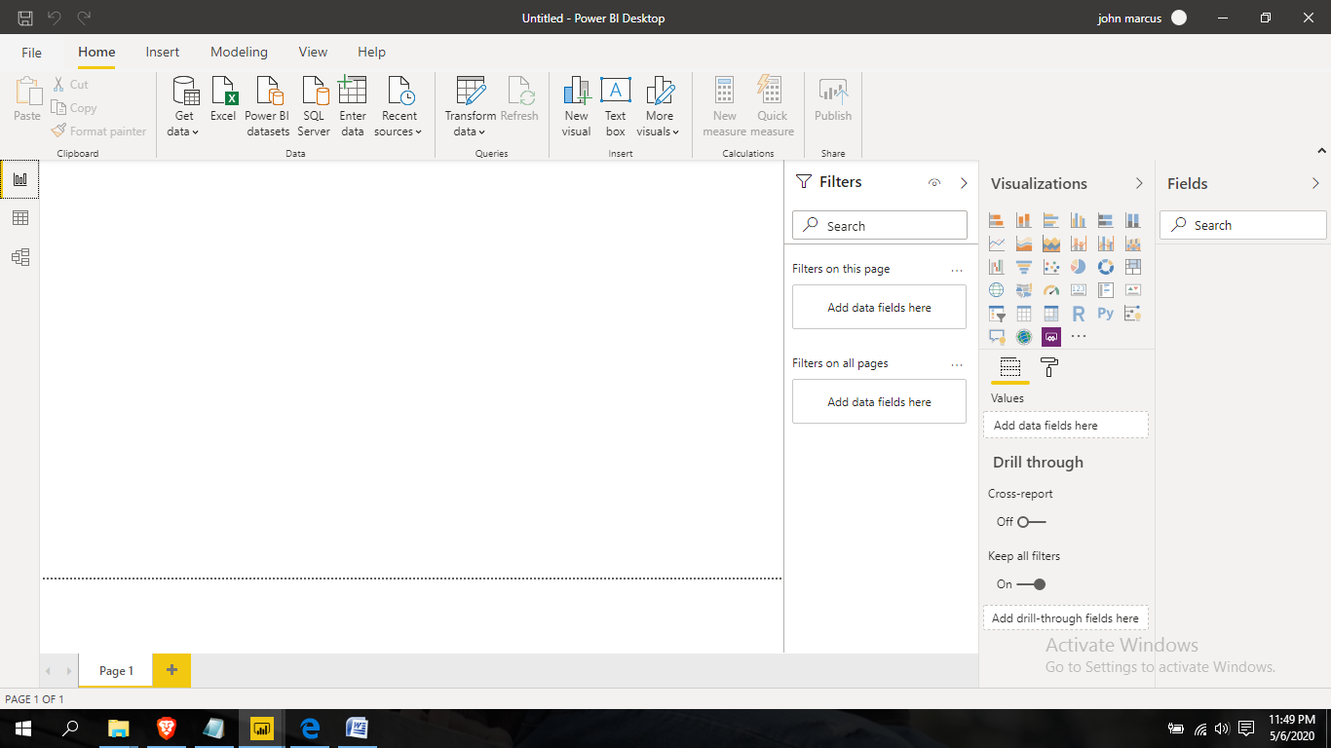

**2 - Prepare a document and with the following screenshot**

*− Report View*

*− Data View*

*− Model View*

*–Power Query Editor*

*− Advance Editor*

**i). Report View**



**ii). Data View**

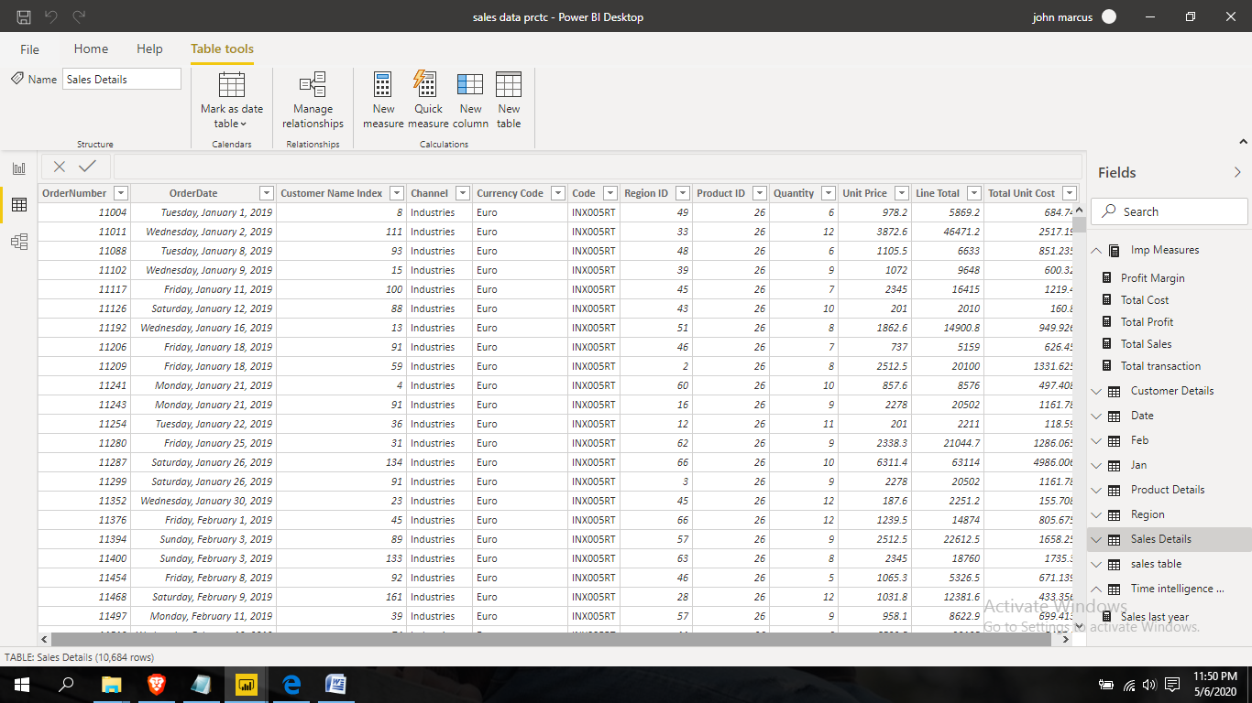

**iii). Model View**

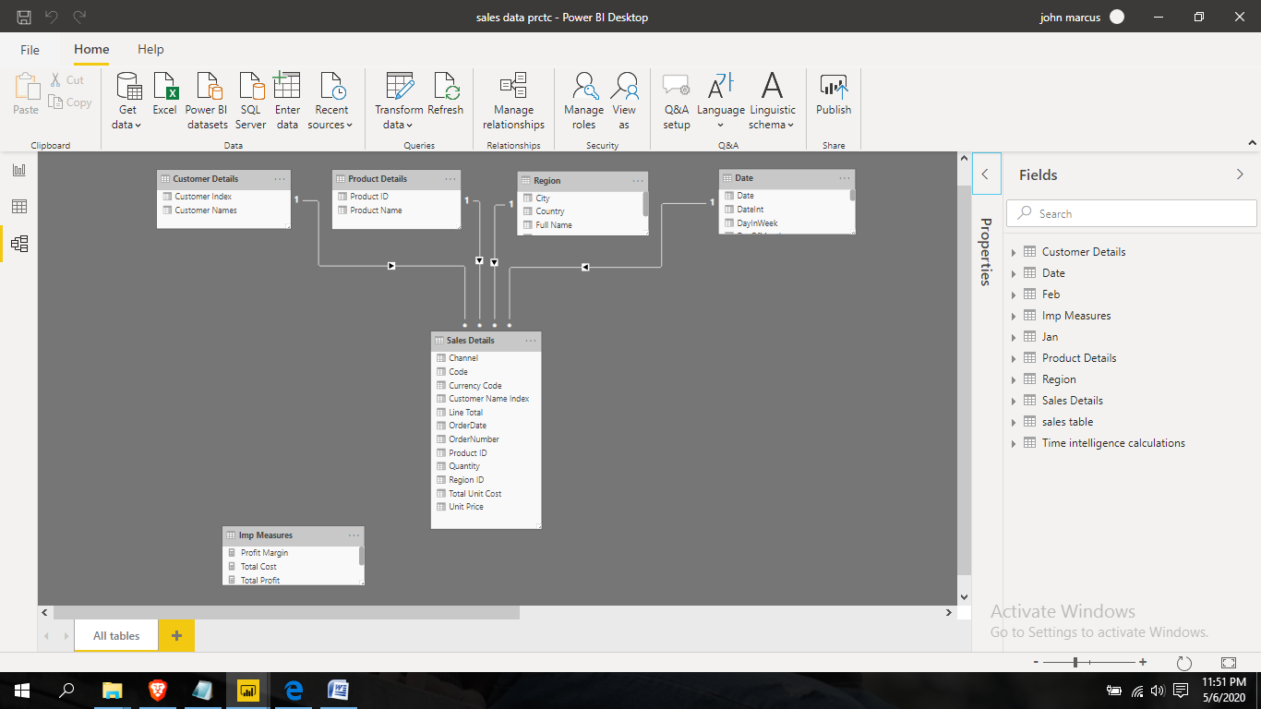

**iv). Power Query Editor**

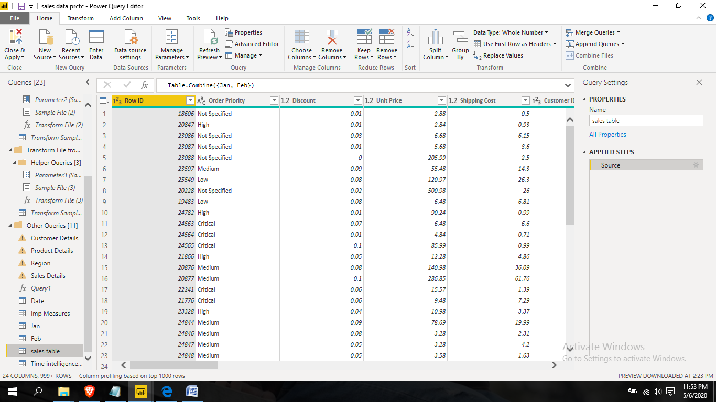

**v). Advance Editor**

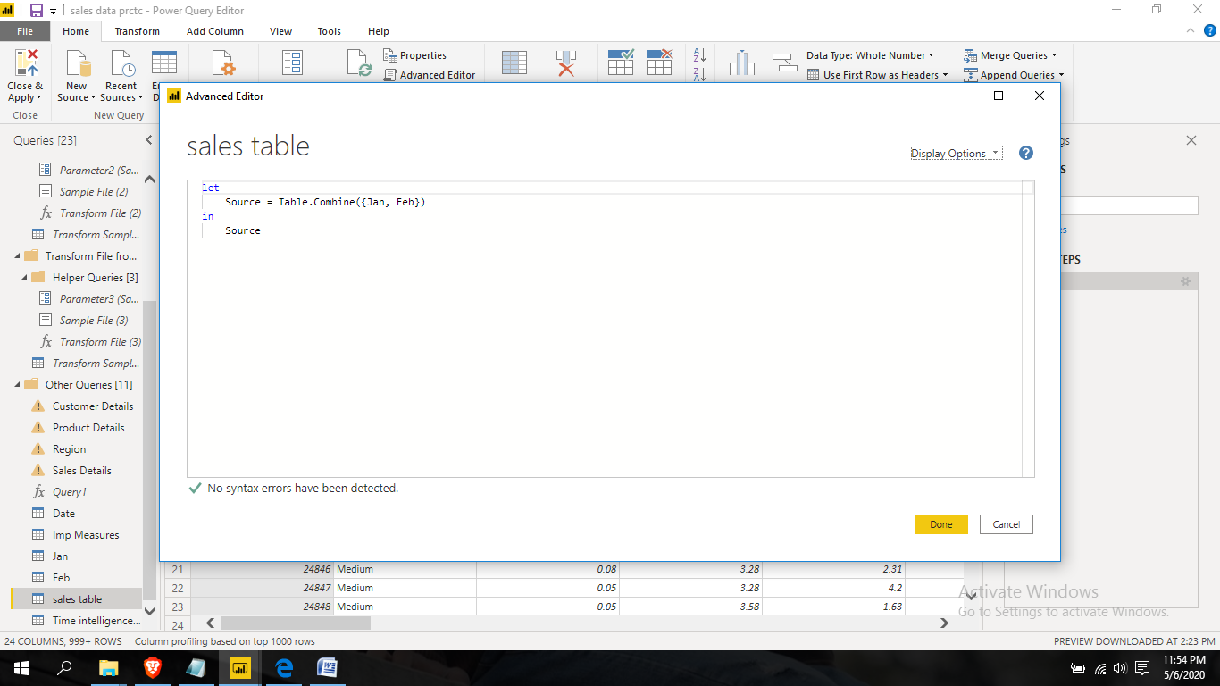

**3- Prepare a document with details of the following along with their price**

*− Power BI Desktop*

*− Power BI Pro*

*− Power BI Premium*

**Answer**

1. **Power BI Desktop:-** The Power BI Desktop offer vide options to play with data and analyses data. You will explore the following functions.

***Connect to your data***, wherever it is - Access data from hundreds of supported on-premises and cloud-based sources, such as Dynamics 365, Sales force, Azure SQL DB, Excel, and SharePoint. Ensure it’s always up to date with automated, incremental refreshes. Power BI Desktop enables you to develop deep, actionable insights for a broad range of scenarios.

***Prep and model your data*** with ease - Save time and make data prep easier with data modeling tools. Reclaim hours in your day using the self-service Power Query experience familiar to millions of Excel users. Ingest, transform, integrate, and enrich data in Power BI.

***Provide advanced analytics*** with the familiarity of Office, Dig deeper into data and find patterns you may have otherwise missed that lead to actionable insights. Use features like quick measures, grouping, forecasting, and clustering. Give advanced users full control over their model using powerful DAX formula language. If you’re familiar with Office, you’ll feel at home in Power BI.

***Create interactive reports*** customized for your business - Create stunning reports with interactive data visualizations. Tell your data story using a drag-and-drop canvas and [hundreds of modern data visuals](https://appsource.microsoft.com/marketplace/apps?corrid=fa25b895-e982-4743-8597-2263feea9f10&omexanonuid=0c267553-56c6-4282-afd9-60ec04df0504&page=1&product=power-bi-visuals&src=office) from Microsoft and partners—or create your own, using the Power BI open source custom visuals framework. Design your report with theming, formatting, and layout tools.

**Pricing -** Free, intended for small to midsize businesses

**Limits of Power BI Desktop** - Power BI, Desktop allows you to connect to data sources to Power BI, with limits of total amount of data you can feed in, and how much you can upload at a time. Desktop users get 10GB of total storage in the Power BI cloud, and can upload data 1GB at a time. The ***catch*** with Power BI Desktop is that you can’t share anything with your peers. You can publish reports to the web, but these reports will then be made public, which isn’t ideal when you’re dealing with proprietary business data.

1. **Power BI Pro:-** Power BI Pro is the full version of Power BI, complete with the ability to use Power BI for both building dashboards and reports and unlimited viewing, sharing and consumption of your created reports (and reports shared by others) - the latter not possible with Power BI Desktop.

A breakdown of Power BI Pro’s differences against Power BI Desktop:

* Ability to embed Power BI visuals into apps (PowerApps, SharePoint, Teams, etc)
* Native integration with other Microsoft solutions (Azure Data Services)
* Share datasets, dashboards and reports with other Power BI Pro users
* Can create App Workspaces and peer-to-peer sharing

Power BI Pro is licensed by individual user. For example, if your organization has 20 people that need to full capabilities of self-service BI to create dashboards and reports, you need 20 licenses of Power BI Pro, which gives these users full access to creation of reports and unlimited consumption (viewing) of any created content.

If you have a lot of users, Power BI Pro can obviously become quite expensive - but there’s a better option if you have more users that need to consume reports than use Power BI for creating reports, which we detail below.

**Pricing of Power BI Pro -** The Pro plan costs $9.99/user/month. It includes data collaboration, data governance, building dashboards with a 360-degree real-time view and the ability to publish reports anywhere. Users can try it a free trial for 60 days before purchasing the subscription.

1. **Power BI Premium:-**The Power BI Premium license is not a per-user license like a Free or Pro License. Instead, Power BI Premium license provides a dedicated unit of capacity for all users in the organization. This dedicated capacity (aka Premium Workspace) can be used to host large datasets up to 50GB while offering a total storage of 100TB in the cloud.

Power BI Premium [features](https://powerbi.microsoft.com/en-us/documentation/powerbi-premium-faq/) allow businesses to:

* Share reports across an enterprise without requiring recipients to be individually licensed
* Scale performance: dedicated hardware and capacity, maintained by Microsoft, for your organization to allocate, scale, and control according to your business needs
* Less restriction on workspace sizes (Currently up to 100 TB for your workspace, depending on Premium capacity purchased)
* Less restriction on refresh rates (Currently up to 48x refreshes per day)
* Ability to maintain Power BI reports on-premises with Power BI Report Server
* Support for Power BI embedded solutions with APIs for custom development (Separate SKUs are also available for embedded-only scenarios)

Additionally, you should be aware of some of the limitations of the service:

* Typically, Premium will only be cost effective for organizations with large deployments or a large number of read-only users
* Power BI Premium requires a Power BI Pro subscription for authors
* Power BI consumers (readers) can’t share in Power BI Premium. Sharing (even in Premium) requires a Pro license

It enables your organization to use your own dedicated capacity and hardware rather than relying on Microsoft’s shared capacity. Although you will in fact need to determine said capacity accurately and ensure that it has the capabilities to handle your reporting and analysis needs. This allows for much larger scale and better performance if you size the capacity properly. Microsoft offers three sizes for Premium capacity and each come with a different number of v-cores and memory size Power BI Premium is for use in large organizations with a great number of users that need to collaborate in real time. The application is geared towards addressing the challenges of large enterprise deployments and workloads.

**Pricing of Power BI Premium-** The Premium plan starts at $4,995 a month per dedicated cloud compute and storage resource. This does not include the cost of licensing for individual Pro and Free licenses required for each user in your organization.